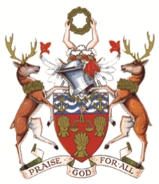

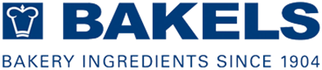

The Worshipful Company of Bakers announces a Short Course for 2024:

September 18-20th
at the Bakels Innovation Centre at Bicester in the UK

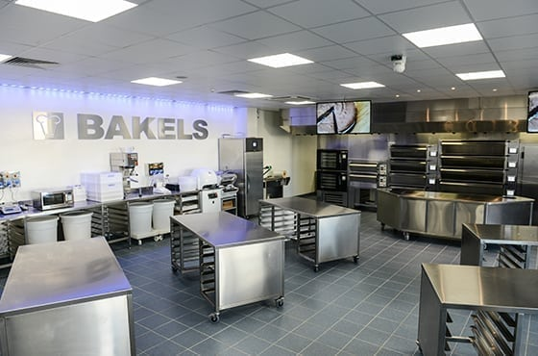

The Bakels Group was originally established in 1904, and the company as we know it today is largely the result of the vision and lifetime work of Bernard J Bakels; who led the company into ingredients manufacturing with the establishment of Nordbakels in Sweden in 1943. Through a combination of investment and innovation the company and its portfolio has grown, and this successful mix continues to be applied with investment increasing every year to accompany innovative new product developments.

Bakels manufactures and distributes a wide range of ingredients, some of which are tailormade for industrial and in-store bakeries while others are specifically developed for the Craft and Foodservice sectors. Bakels has well established sales and technical teams focusing on serving the specific needs of each sector of the baking industry and owes its success not just to investment in facilities and innovation but also in recognising the importance of training people, both young and old, in essential bakery skills.

We are very grateful to Bakels for rearranging their immensely successful short course at the Innovation Centre at Bicester invite students, apprentices and trainees to apply for places.
Students will be responsible for their own travelling costs to and from Bicester; but the award includes accommodation and meals, travel between the hotel and the Innovation Centre and a set of bakery whites. Students are asked to bring their own safety shoes.

Entry criteria:
N.B. Please DO NOT apply unless you are definitely available on the dates of this course.

This course is offered to bakery students, apprentices and trainees in the industry from the UK and Ireland only. Applications are invited from students in the second or final year of their full-time bakery education at college, or the equivalent level of a workplace-based training course or apprenticeship. You must have at least 1 year of experience of working in a bakery – for college students this will be placements, internships, etc., and you will be asked to submit details of a product you have worked on during your experience. Full details are on the application form.

You must be aged 18 or over at the time of the course.

Closing date for applications is MONDAY 6th MAY, 2024. Applications received after this date will not be considered. Selected candidates may be required for a virtual interview during the week commencing May 27th: you will be notified during the week commencing May 20thif this applies to you.

The final selection of delegates will be at the discretion of the Worshipful Company of Bakers and their decision is final.

